1. What is multi threaded programming ?

* Client sends the request to server
* The server will first create a thread T1 , Which will start task1
* In a multithreaded approach which one thread starts one task and then it sees another task2 after that then immediately another new Thread T2 will be created

And that T2 will start the task2 .

* So while the T1 thread is waiting for task one to complete in parallel the new thread T2 will start task2 and therefore both tasks are being executed in parallel
* Similarly it performed for task3 & task4
* This approach is good for CPU intensive tasks where many tasks has to be performed parallelly
* It is having more cores means they are much better for multithreaded programming
* Internet API this multithread approach can be problem , Because multiple thread can create deadlock problems if not properly handled , that why we prefer a single threaded asynchronous approach for JavaScript and node

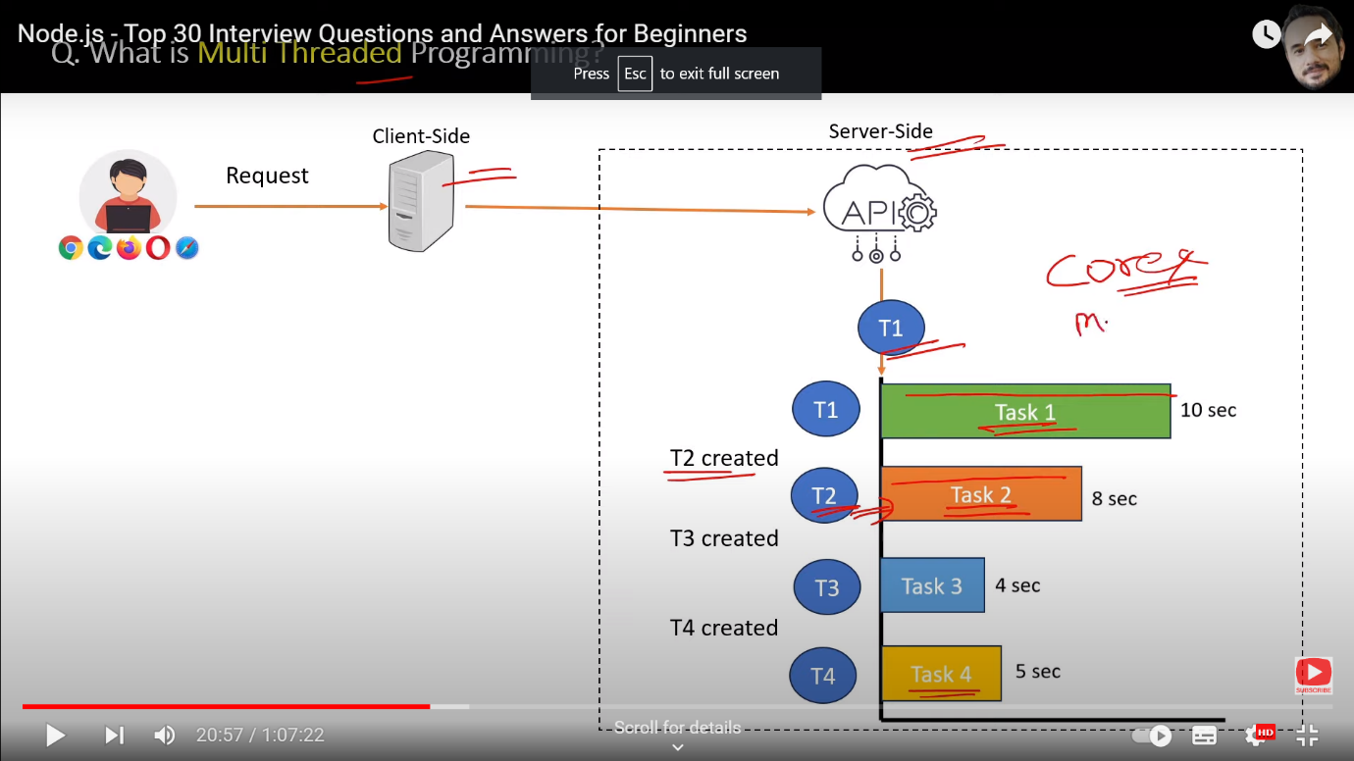

1. What is Asynchronous Programming ?

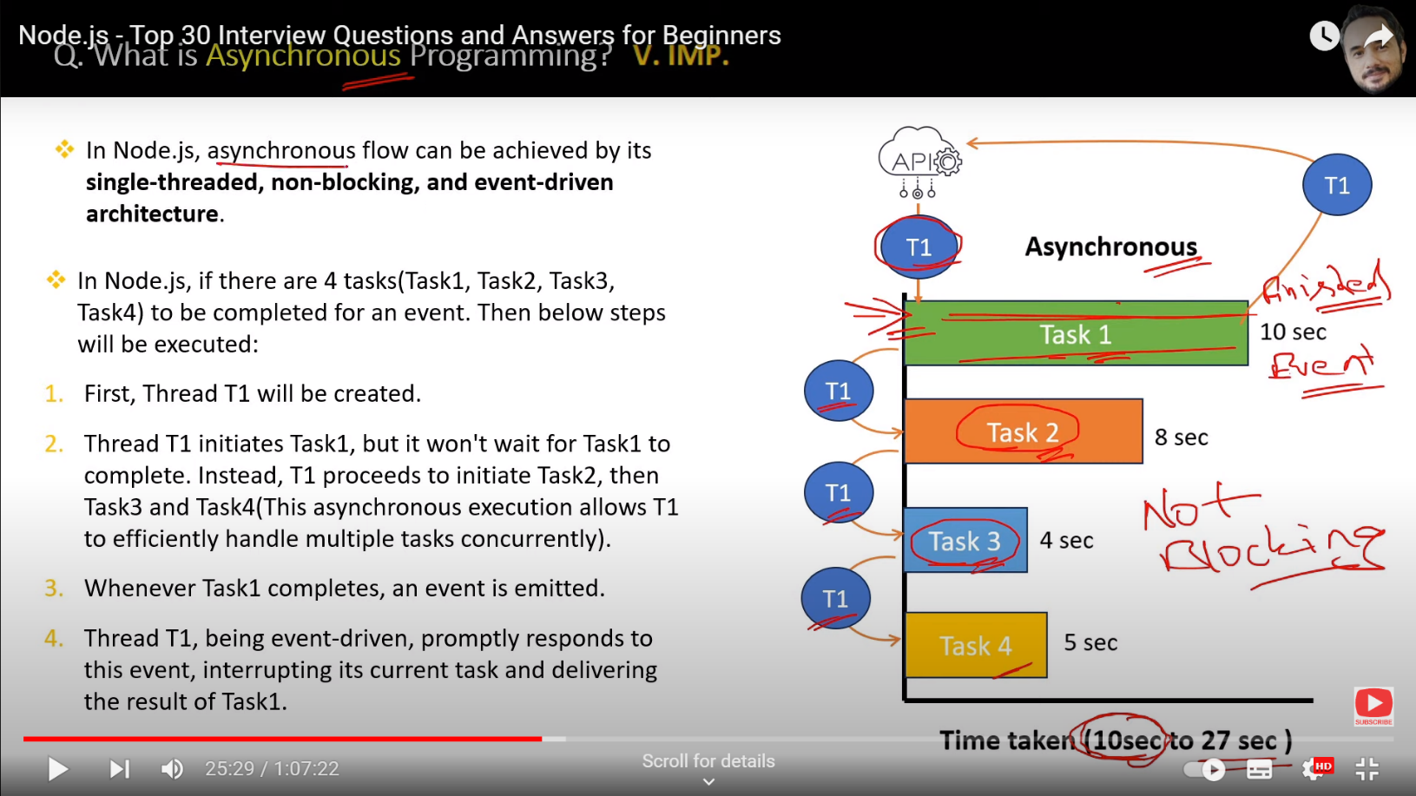

* We know show synchronous programming is not good for performance

Also it’s a blocking approach , That’s problem will solve it here

* Suppose a request has to complete four tasks , then first a single thread is created which will initiate the task1
* Now this T1 will not wait for task1 to be completed, will not wait instead after initiating task1 this thread T1 will immediately jump onto the initiate or start the next task2
* After initiating task2 T1 jumps on to initiate task3 and then task4
* The point is that our single thread T1 just initiating the task and not wating for its completion
* Now u can imaging how in this case our tasks are running concurrently and if u remember in synchronous way the total time was 27 sec, which is the least time
* The total time taken can be 10 seconds in the best case but time will can be something more it depends on your hardware but any case it will be better than the synchronous operation
* First problem we solved time & performance problem
* Another problem was the blocking issue so here task1, task2, task3 & task4 while executing are not blocking the execution of the next task
* When task1 is executing, Task2 in parallel concurrently can also execute so therefore it’s a non-blocking way the synchronous approach
* When task1 is executing independently then this thread1 is busy in starting the other tasks, it is doing its work so how the system will know when task1 one is finished so there comes the role of the events in node whenever any task is completed or finished, It will raise an event
* So the that event will immediately listen or heard by our thread T1 and our thread will stop immediately stop whatever it is doing at that point of time
* T1 will do on priority basis it will immediately report the task completion to the source and then again T1 will resume whatever it was doing earlier
* So that why we called nodejs has an asynchronous programming approach and also the event driven architecture

1. What is the difference between Synchronous And Asynchronous Programming ?

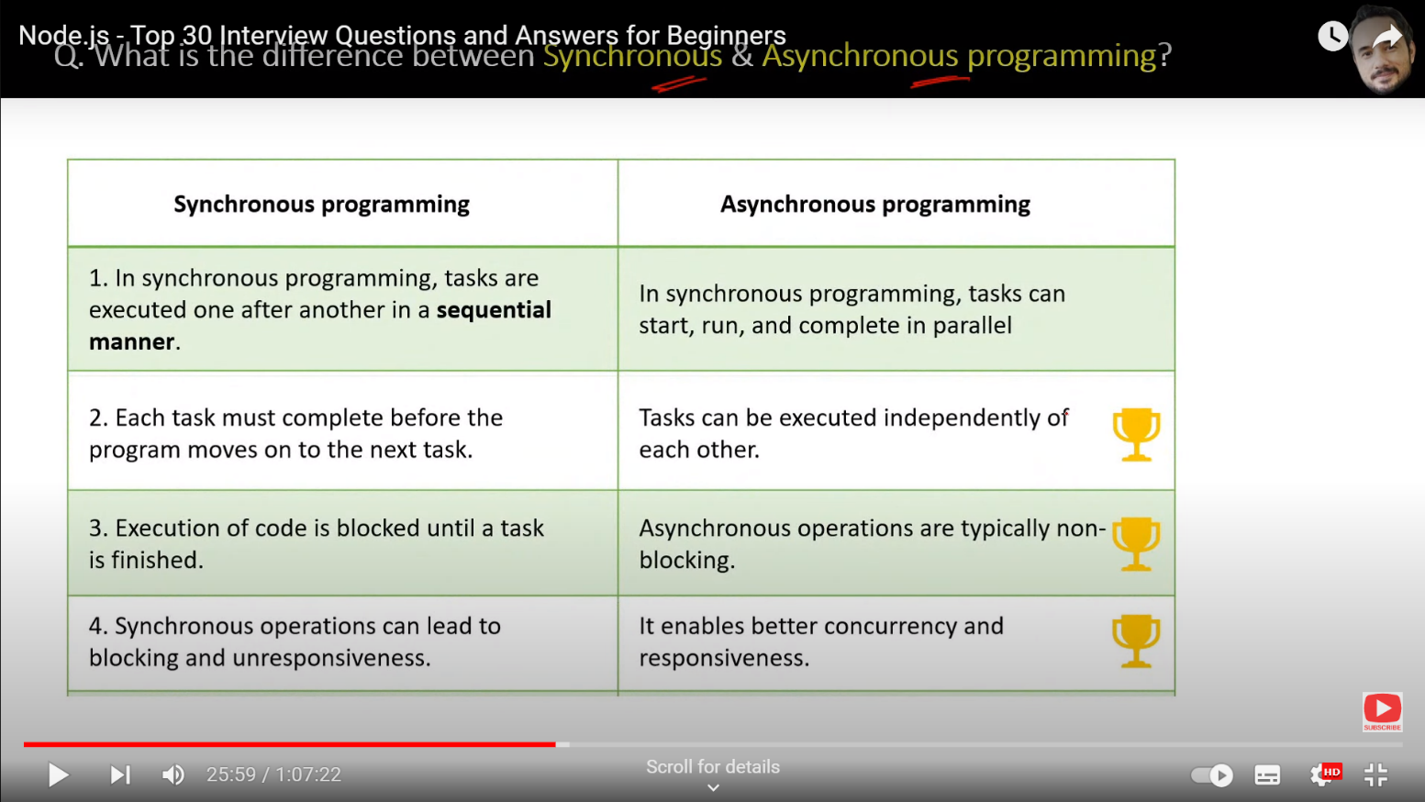

1. What are Events, Event Emitter, Event Queue, Event Loop & Event Driven ?

* Event is like a single something has happened in a program like a notification , like action has happened
* If u know we have these click events in the UI, Now theses events are notification must have some source from where they are these events are originated , So these sources are called event emitters , Who generate the events like E1 and E2
* All generated events are stored in queue Which we called event queue
* Node will pick one event at time and event handler or we can also say event listener will perform the code as per event requirement

Basically, here we write the code how will handle the event in your application

Event handler is nothing but it’s function

In case of threads, it is written by the node how to handle it asynchronously inside the node run time environment

* The next event will pick by the event handler from the event queue and then it goes like next event
* Event Loop picks up the event from the event queue and executes them in order they were added
* 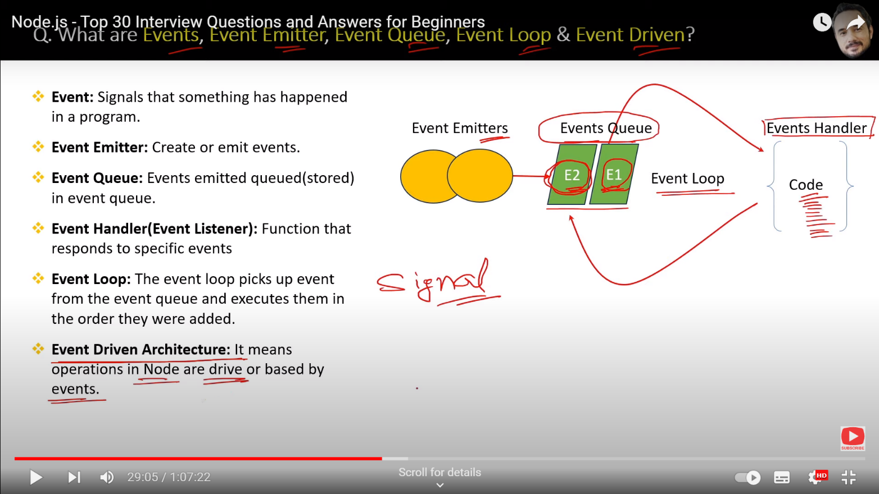

1. What are the main features and advantages of nodejs?

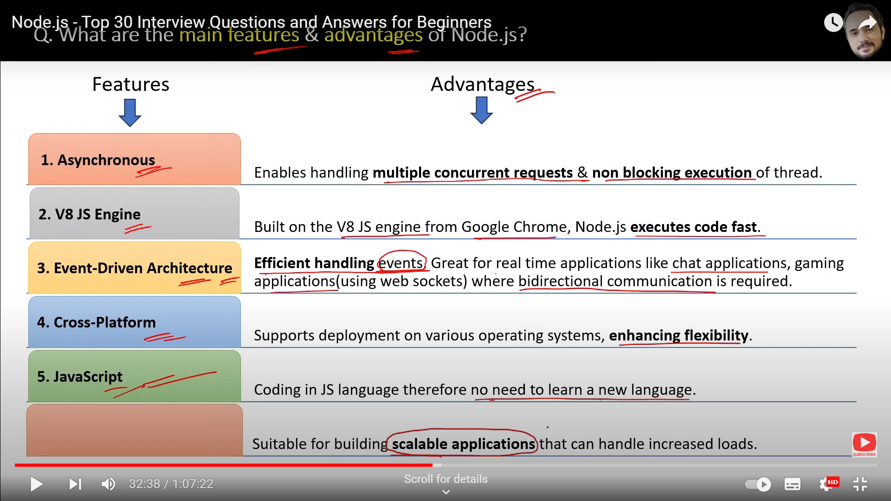

1. What are the disadvantages of node ? When to use and when not use node ?

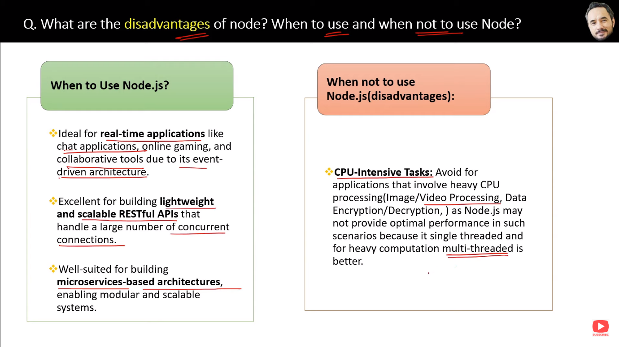

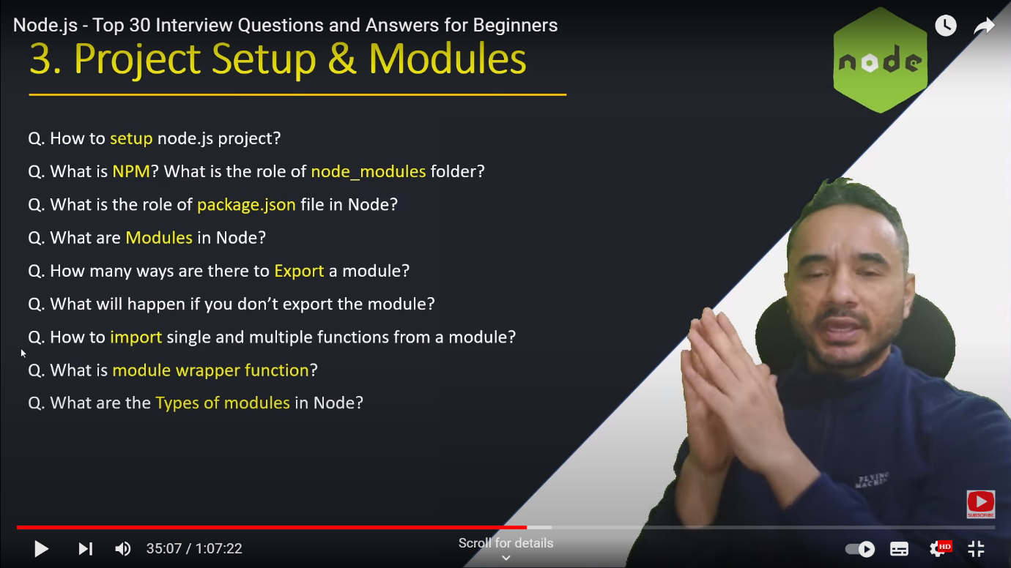

1. How to setup node.js Project ?

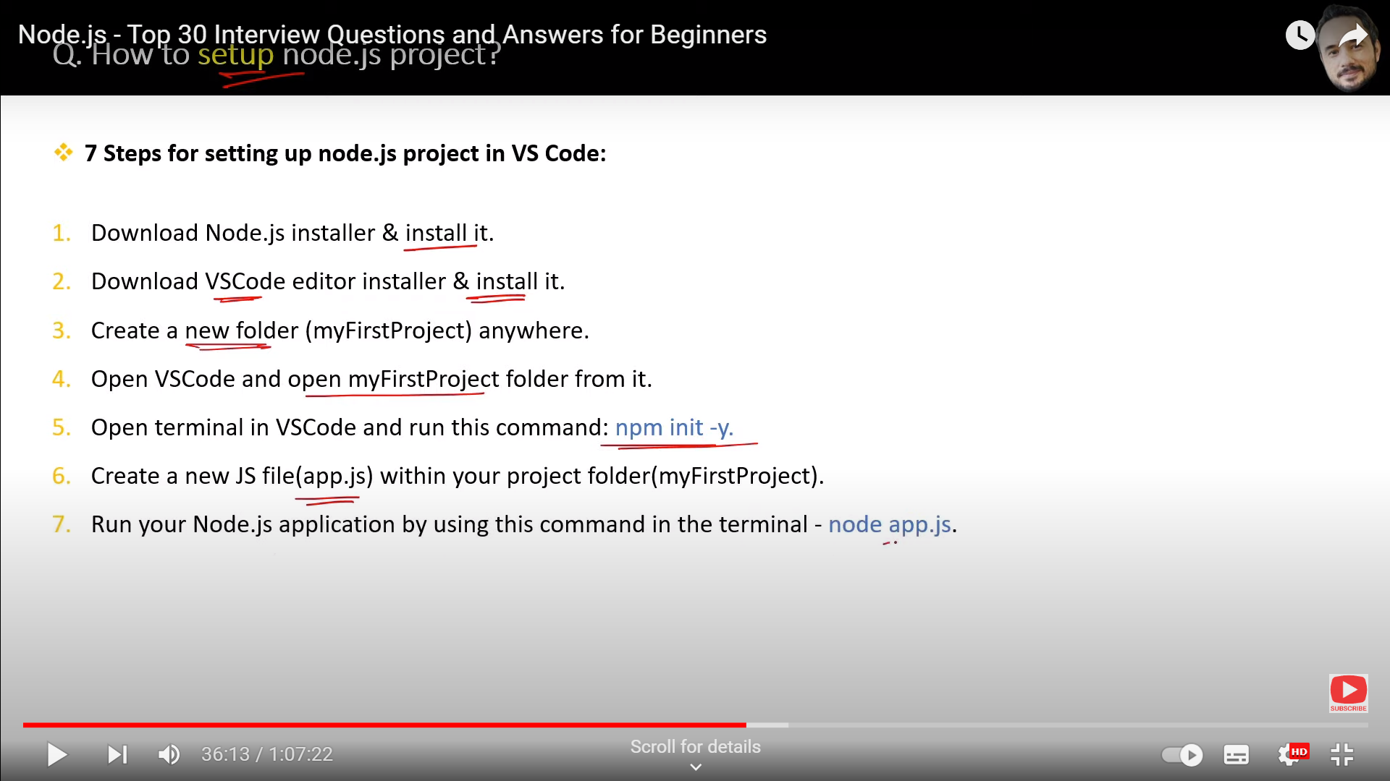

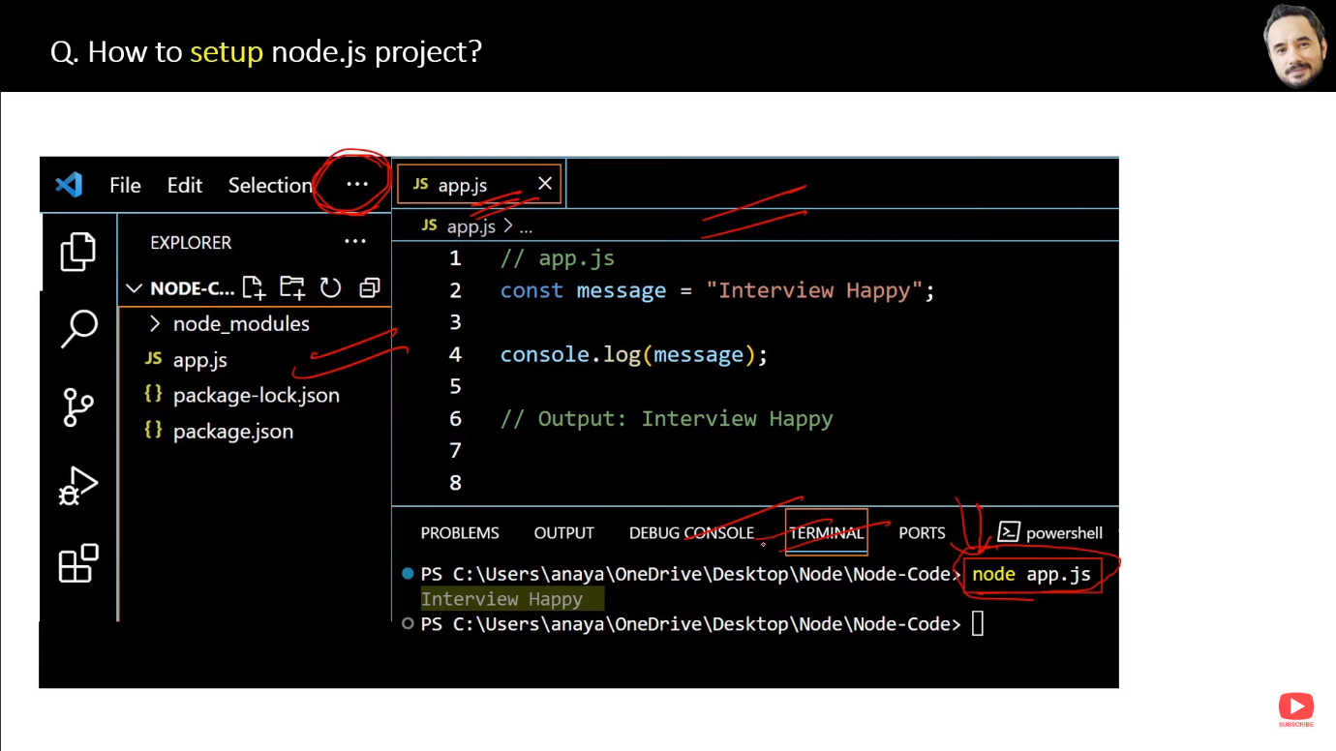

1. What is NPM ? What is the role of node_modules folder ?

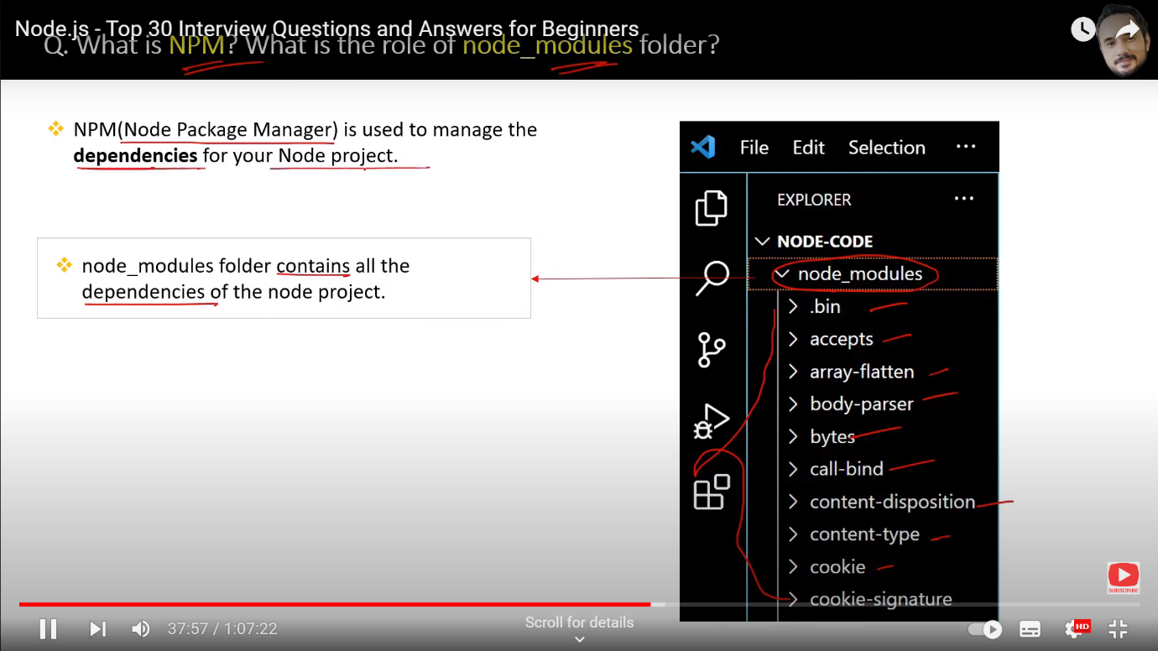

1. What is the role of package.json file in node ?

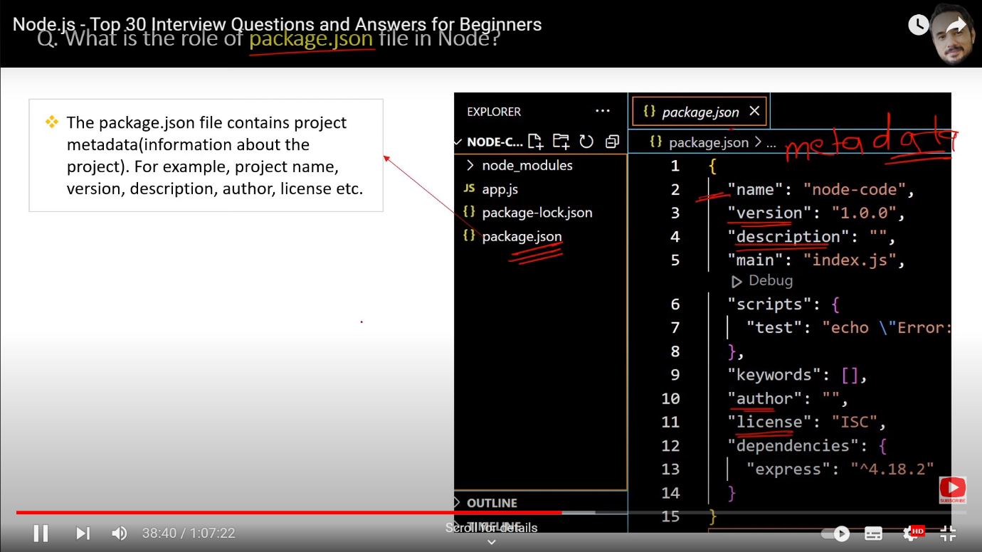

Just like a book is there so it has content inside the book , but the name of the book, author of the book , this is the information meta data about the book

1. What are modules in node ? What is the difference between a function and module ?

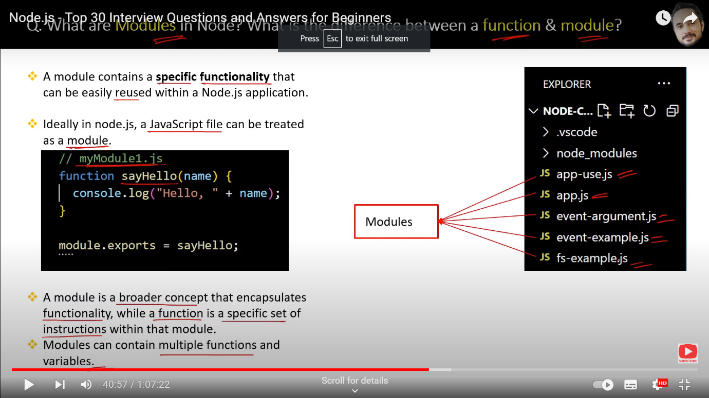

1. How many ways are there to Export a module ?

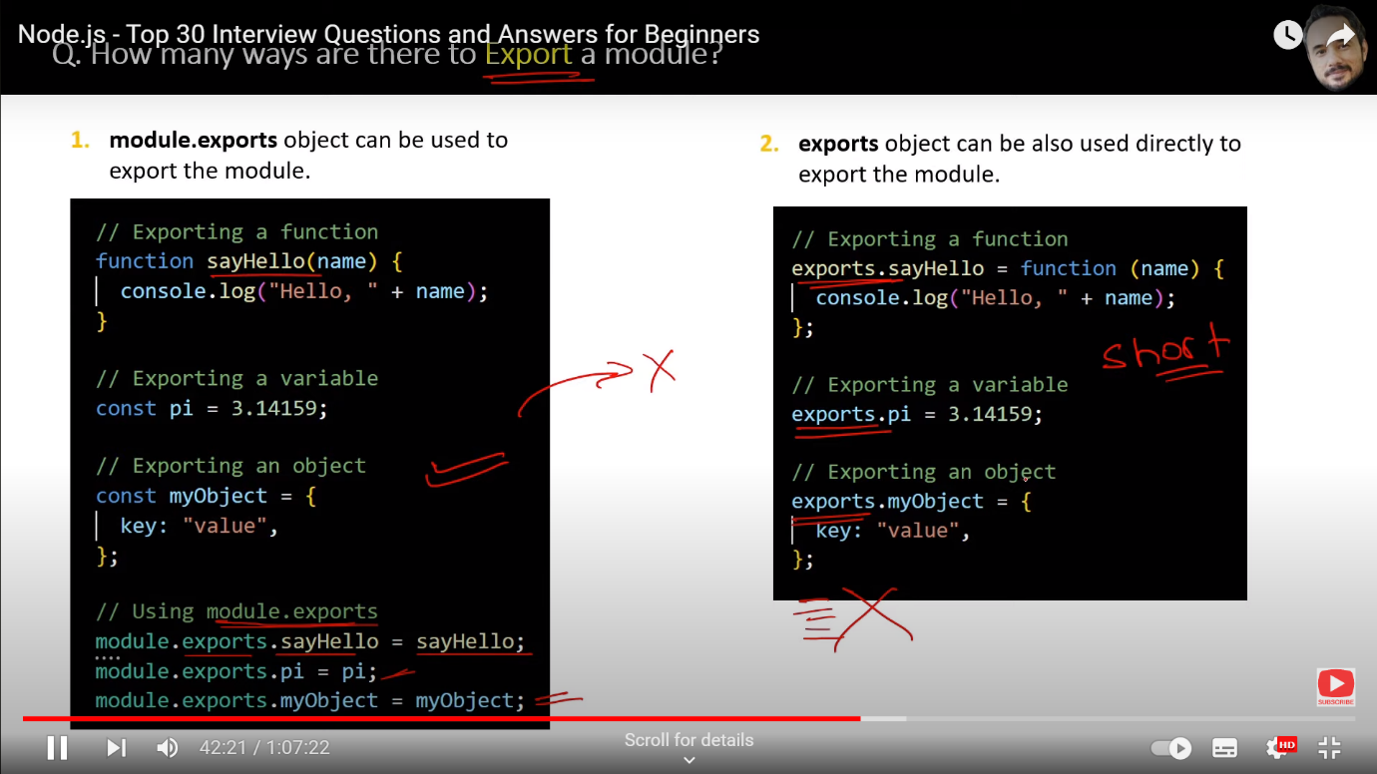

1. How to import single and multiple functions from a module ?

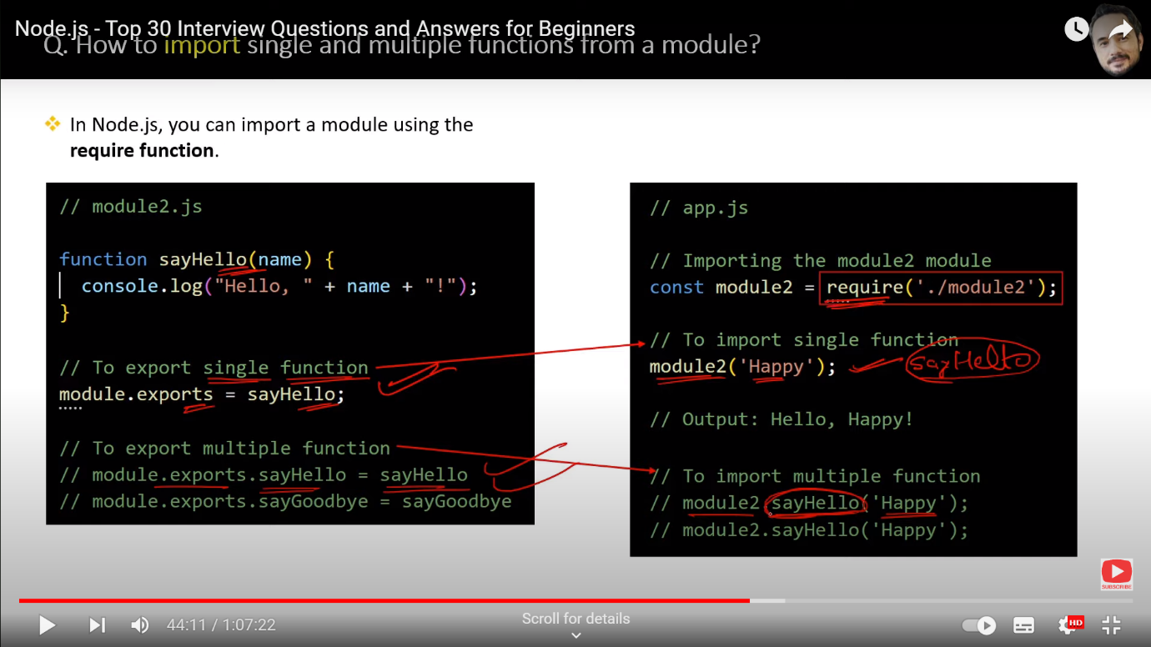

1. What is module wrapper function ?

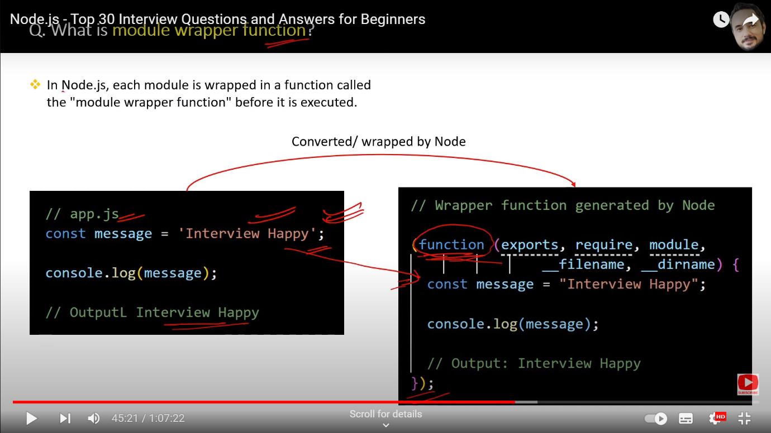

1. What are the types of modules ?

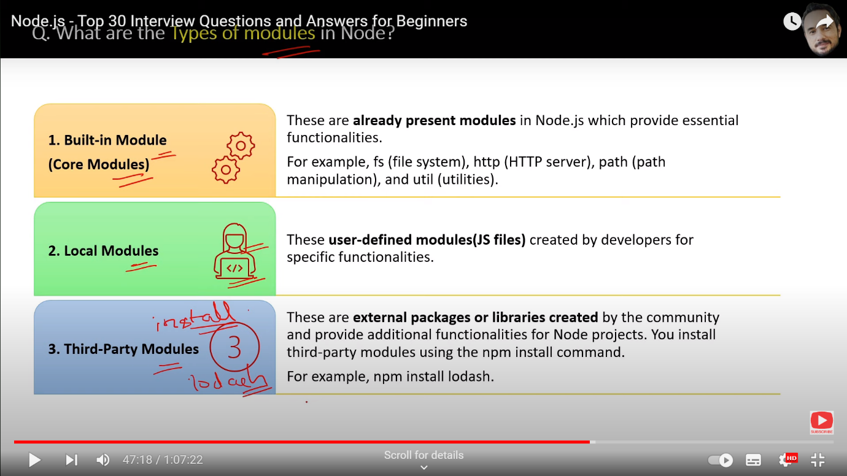

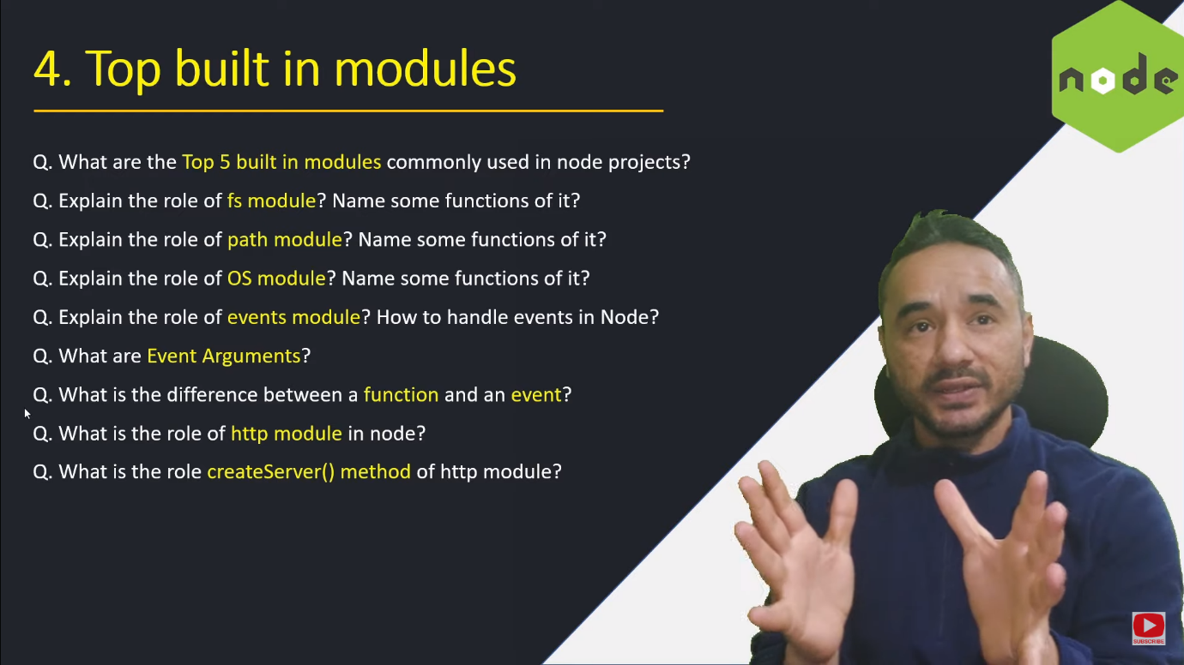

1. What are the top 5 built in modules commonly used in nodejs project ?

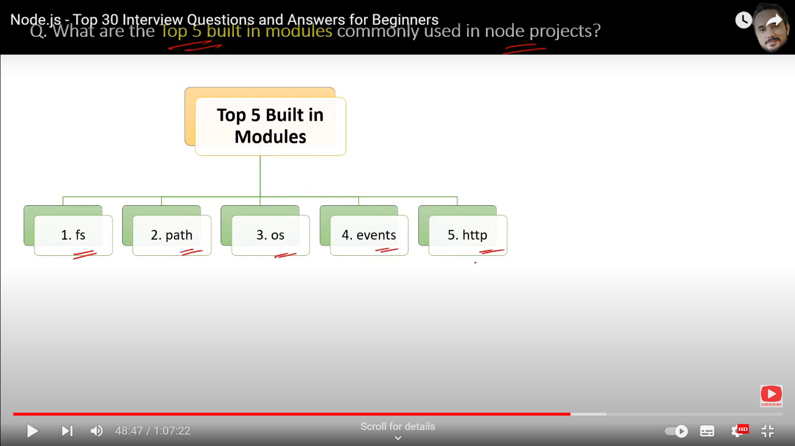

1. Explain the role of FS module and name some functions of it ?

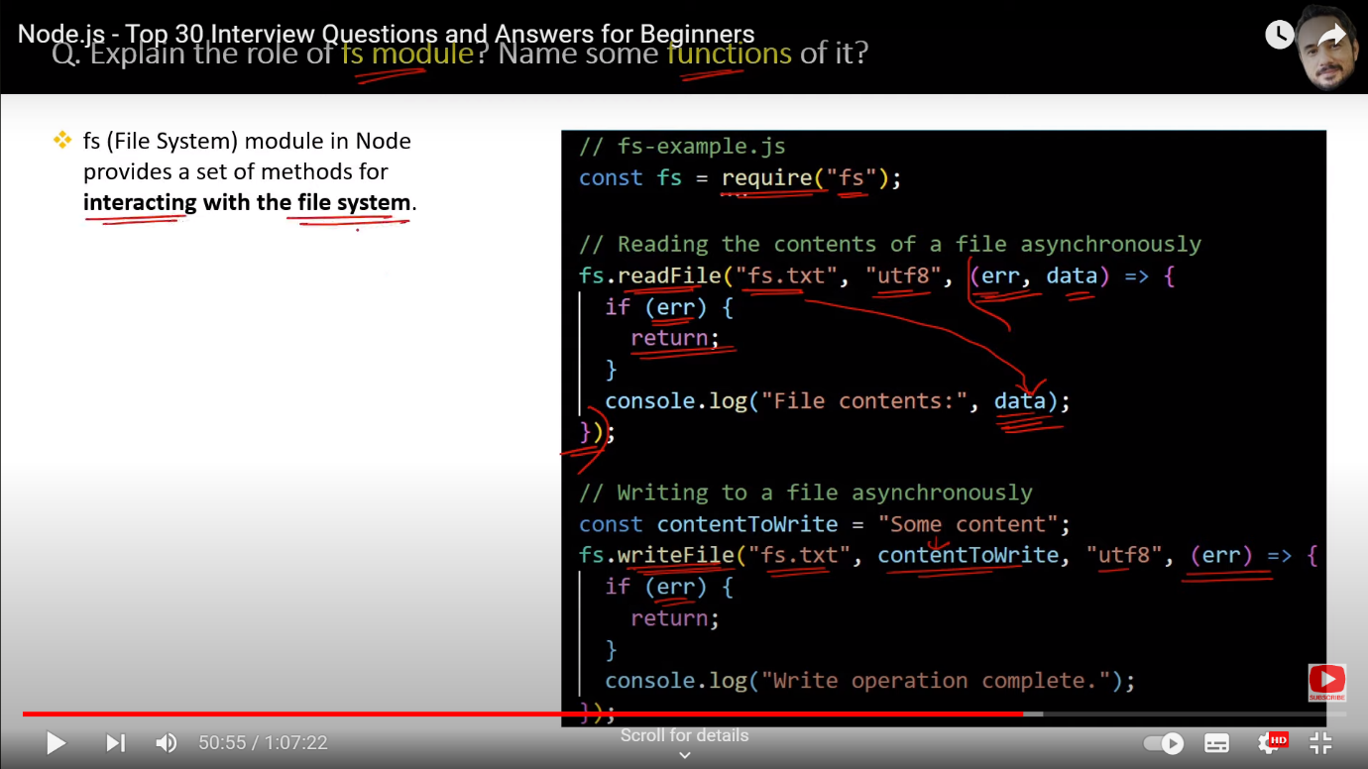

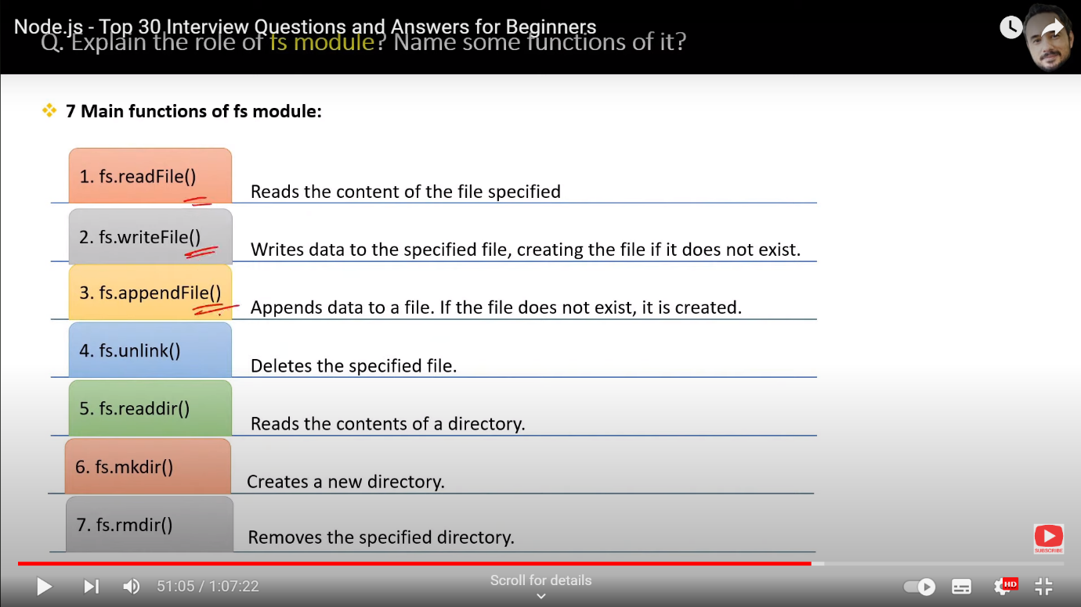

1. Explain the role of Path Module ? Name some function of it ?

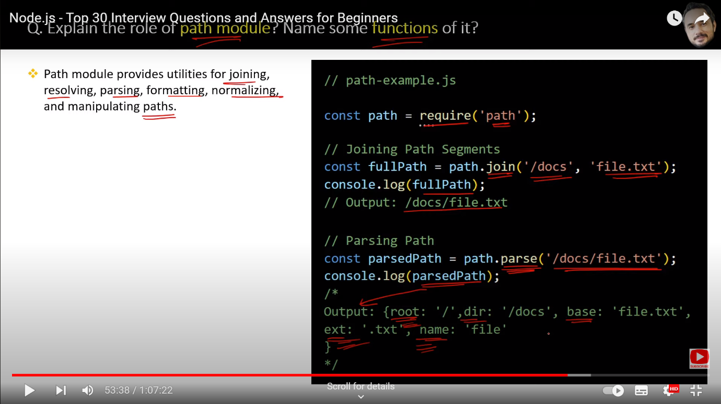

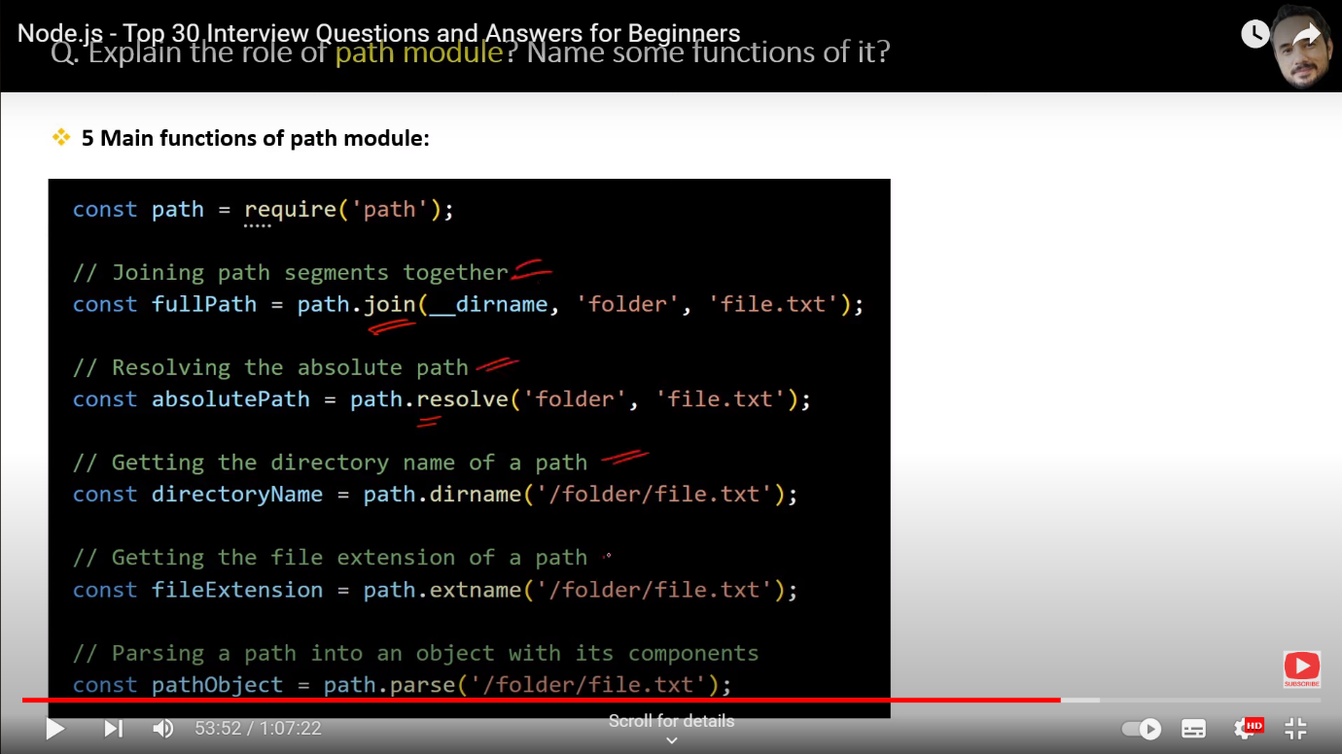

18.Explain the role of OS module ? Name some function of it ?

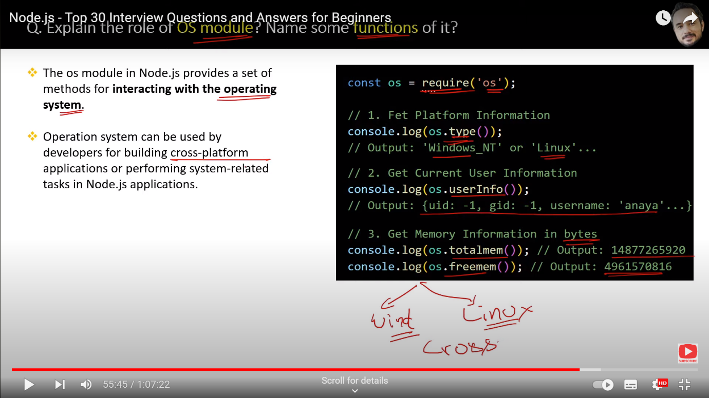

1. Explain the role of events module ? How to handle events in node ?

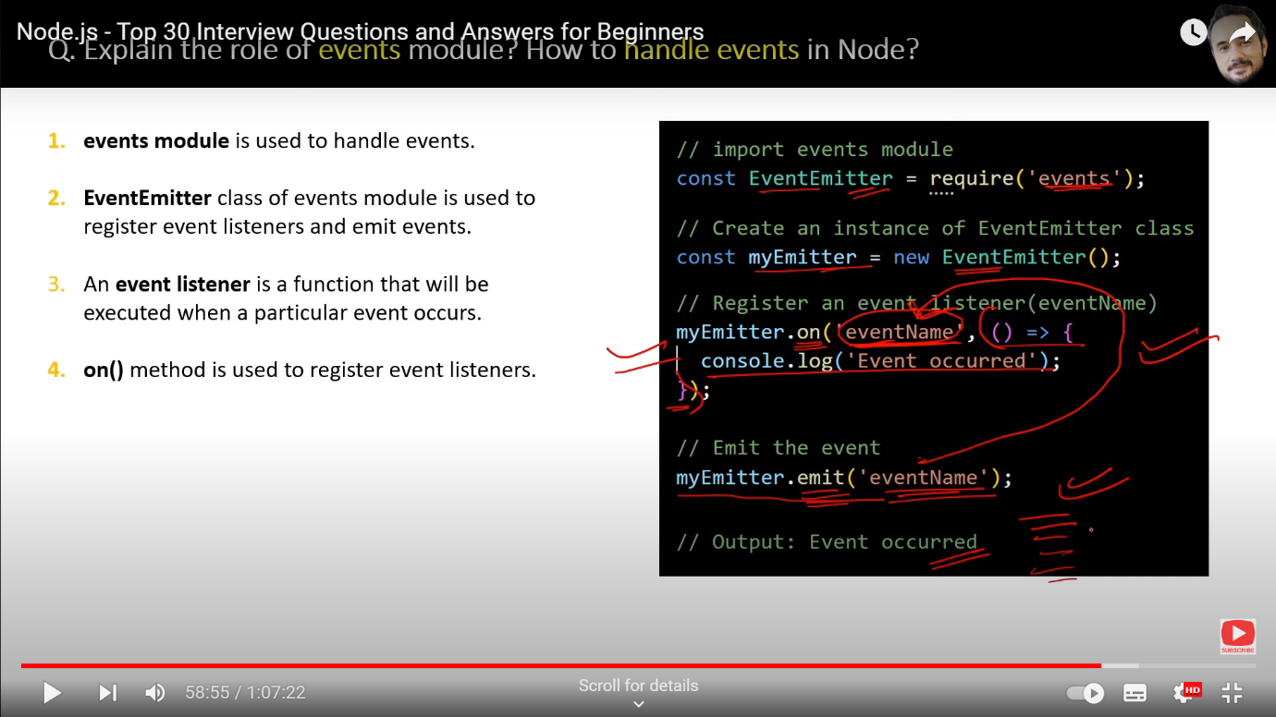

20.What are Event arguments ?

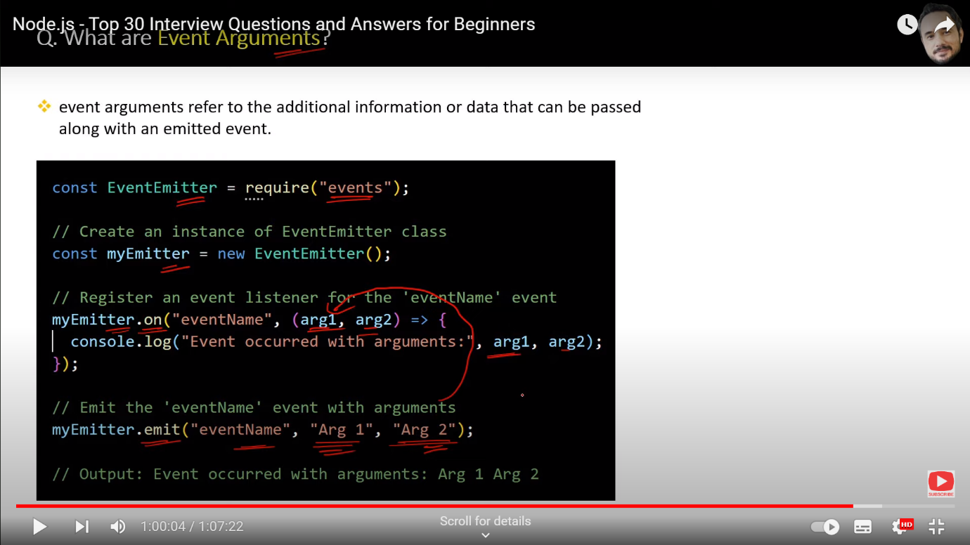

1. What is the difference between functions and events ?

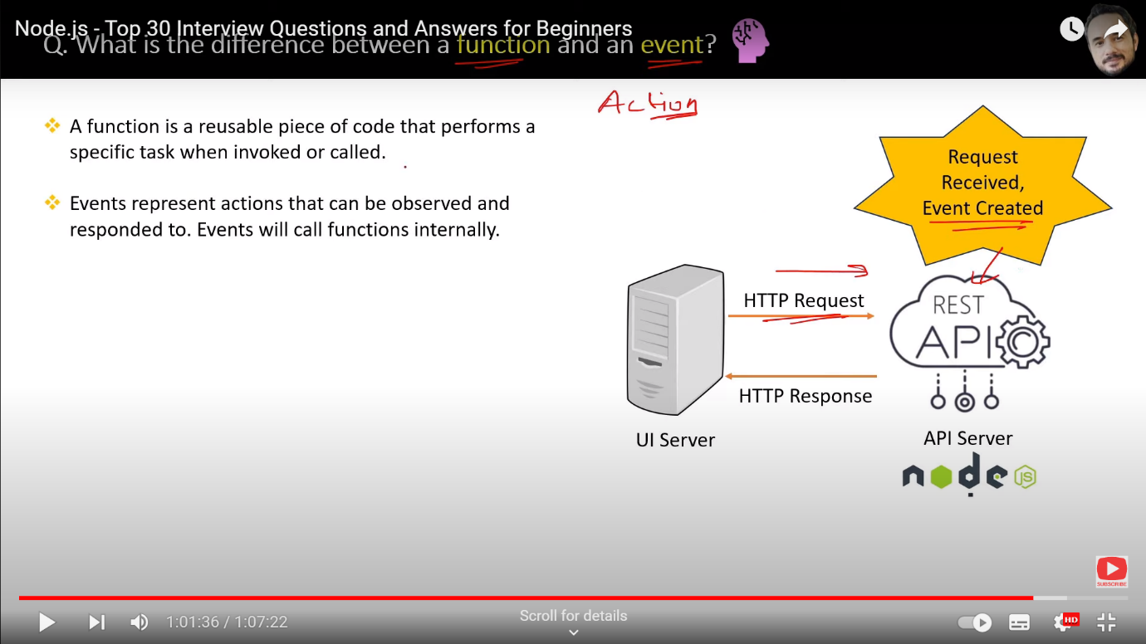

1. What is the role of http module in node ?

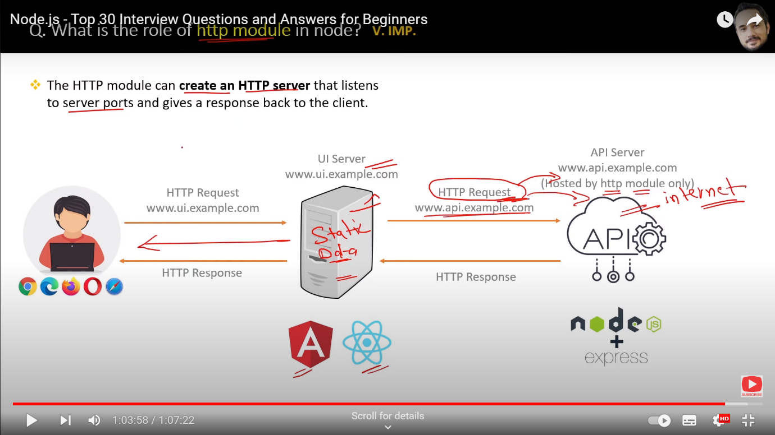

1. What is the role of createServer method of Http Module ?

